HFSC HFSW Proclamation Copy 2025:

Proclamation

*whereas* The effects of home fires are far-reaching and longstanding. A house fire can become deadly in as little as two minutes because of common synthetic furnishings that burn fast producing toxic smoke, lightweight construction material and open designs used in today’s construction, and emerging technology such as lithium-ion batteries.

*whereas* Homes should be the place where our residents feel safe. In reality, home is where they have the greatest risk of injury or death from fire.

*whereas* Home fires put our firefighters at risk through exposure that can lead to

health issues.

*whereas* Combined with working smoke alarms and proper fire escape planning,

fire sprinklers in all new homes can reverse the effects of home fires*.*

*whereas* By taking part in Home Fire Sprinkler Week, let us recognize that protecting new homes with fire sprinklers will make the future safer for residents, first

responders, and entire communities for generations to come.

NOW, THEREFORE I, __________________________________________________________________________________________ , by virtue of the authority vested in me, do hereby proclaim:

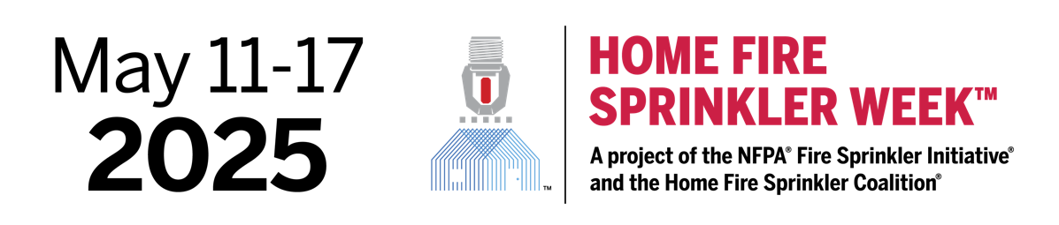

I encourage all residents to educate themselves about the dangers of home fires and the

unparalleled benefits of home fire sprinklers and to begin to embrace this technology in all

of our city’s new homes.